Data Cleaning and Transformation Using Tableau Prep
Question 1

Tableau Prep was used to clean, transform and consolidate multiple datasets into a structured format suitable for analysis. The following steps were undertaken to ensure data quality and consistency across all files.
These were the steps I took to clean the data.
1. Data Consolidation (Union of Files)
All CSV files from 2023, 2024 and 2025 were combined using a union operation in Tableau Prep. This created a single unified dataset from multiple monthly files, enabling consistent transformation to be applied across all records.
This approach improved scalability and eliminated the need for manual processing of individual files. To check if the dataset has been loaded on Tableau Prep, the number of tables must be checked, which was 36 in total, as there were 12 in each year.
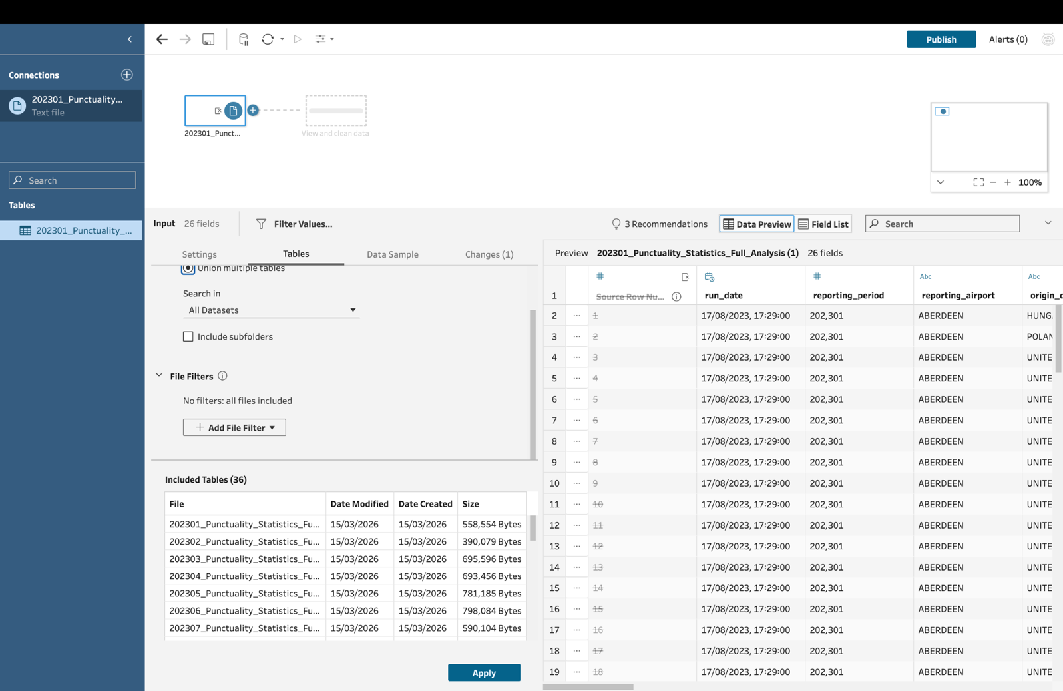
2. Identification and Removal of Duplicate Rows
Duplicate records were identified using the “Identify Duplicate Rows” feature in Tableau Prep. A calculated field was generated to flag duplicate entries based on key fields.
A filter was then applied to:
- Exclude rows marked as Duplicate
- Retain only unique records
This step ensured data integrity and prevented duplication from affecting analysis results.
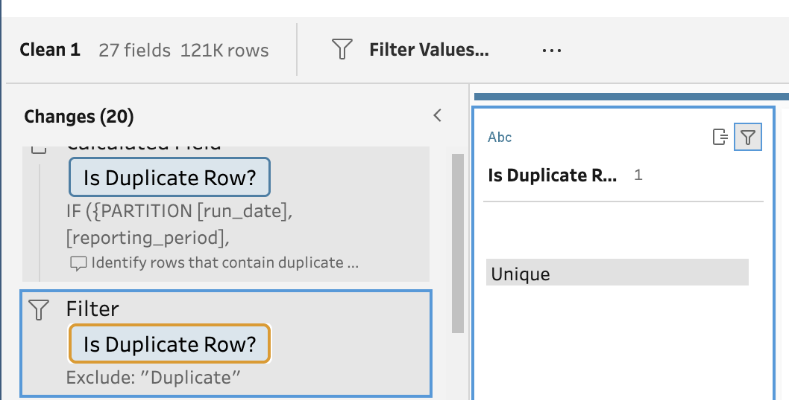

3. Removal of Leading and Trailing Spaces
Text fields were cleaned using the “Trim Spaces” function. This was applied to key columns such as:
- airline_name
- reporting_airport
- origin_destination
This removed hidden whitespace inconsistencies (e.g., “Ryanair ” vs “Ryanair”), ensuring accurate filtering, grouping and sorting within Tableau.
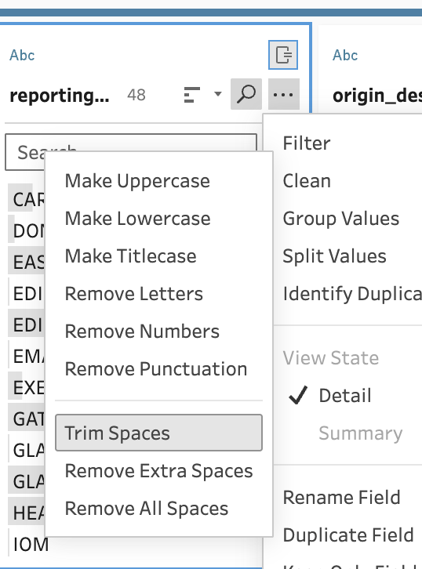

4. Standardisation of Airline Names
The airline_name field contained inconsistencies in capitalisation. To resolve this:
The “Make Title Case” function was applied to ensure consistent formatting. Airline names were reviewed to ensure identical entities were consistently represented. The record was reduced from 401 to 376 after the changed, which is shown below by the screenshots.For example, “RYANAIR” and “ryanair” were standardised to “Ryanair”. However distinct airlines, like “Tui Airways Ltd” and “Tui Fly Belgium” were kept the same as separate entities to maintain data accuracy.This ensured correct aggregation and filtering in reporting.
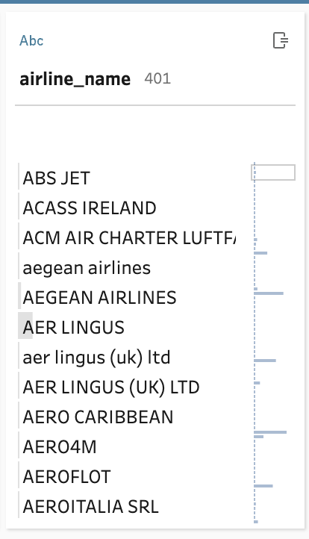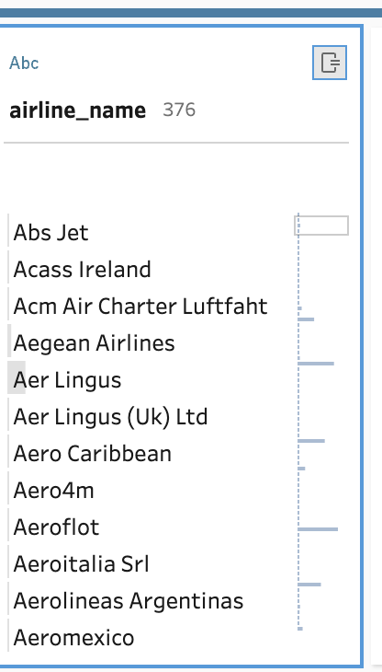
5. Standardisation of Airport Names
The dataset contained inconsistencies where some records used airport codes (like “LTN”, “MAN”) and others used the full airport names. This meant that if any analysis would be executed then the airport code and full airport names would be treated as two separate entities and the conclusion wouldn’t be accurate.

To resolve this:
The “Group and Replace” feature was used. The matching values were grouped and replaced with the full airport name to keep consistency.
For example:
- “NCL” as “Newcastle”
- “MAN” as “Manchester”
This ensured all records used a consistent naming convention, improving clarity and usability in analysis.
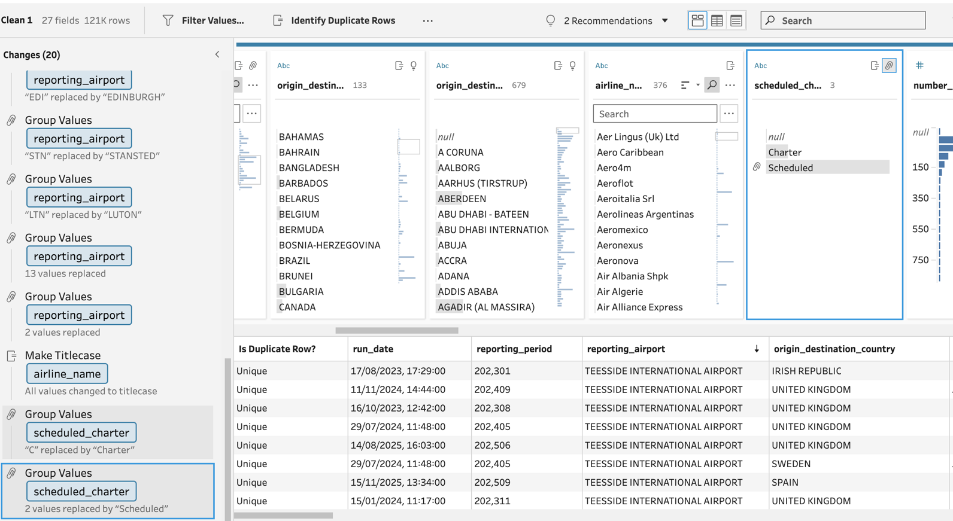
6. Standardisation of Schedule/Charter Field
The scheduled_charter field contained inconsistent labels such as:
- “Scheduled”
- “schedule”
- “S”
- “Charter”
- “C”
A calculated field was created to standardise these values:
- All variations of scheduled flights were renamed to “Scheduled”
- All remaining values were mapped to “Charter”
This resulted in only two values, “Scheduled” and “Charter “. This ensures accurate grouping and filtering in visualisations.
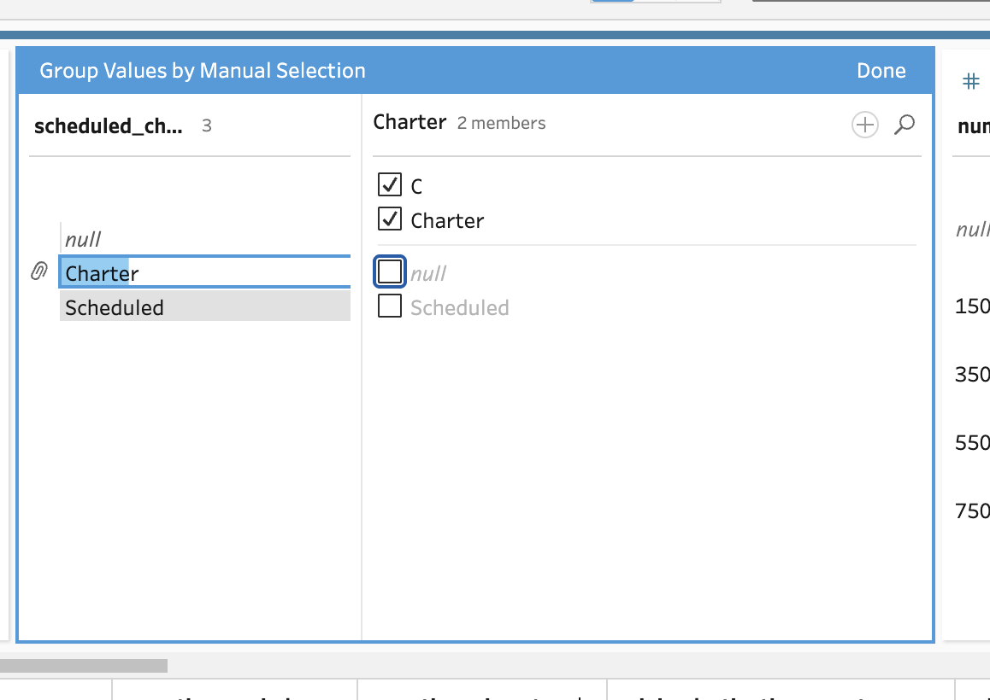

To conclude, Tableau Prep was effectively used to transform raw and inconsistent datasets into a clean and structured format suitable for analysis. Key data quality issues included duplication, inconsistent formatting and categorical inconsistencies, which were all systematically amended. The final dataset is now accurate, consistent and ready for use in Tableau dashboards. Below a screenshot of how many changes were made and, on the side, are the changes made throughout the cleaning process.

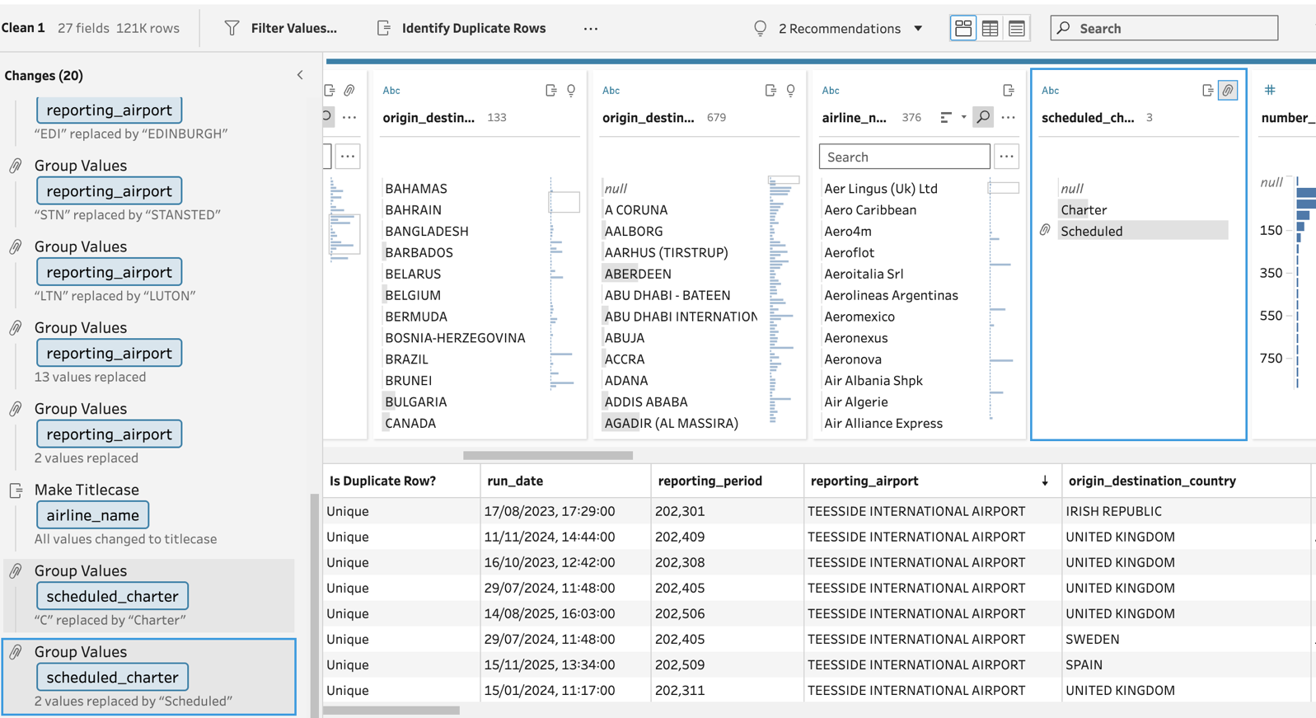

Question 2
A star schema was chosen because it provides a simple and efficient structure for analytical reporting. The central fact table, Fact_Flight_Punctuality, stores the numerical performance measures such as matched flights, cancelled flights, delay percentages and average delay minutes. These are the key values users would aggregate and analyse.
Surrounding the fact table are dimension tables which store descriptive attributes. Dim_Airport, Dim_Airline, Dim_Destination, Dim_Country and Dim_ScheduleType were separated into dimensions because these values are used for filtering, grouping and sorting in reports, and would otherwise be repeated across many rows.
Dim_Date was created from the reporting_period field. Additional attributes such as month, year and quarter were derived from this field to support time-based analysis, including trend reporting and period comparison.
This design reduces redundancy, improves consistency, and makes the data model easier to query in BI tools such as Tableau. It also reflects the cleaning work carried out in Tableau Prep, where airport names, airline names and schedule categories were standardised before being loaded into the warehouse.

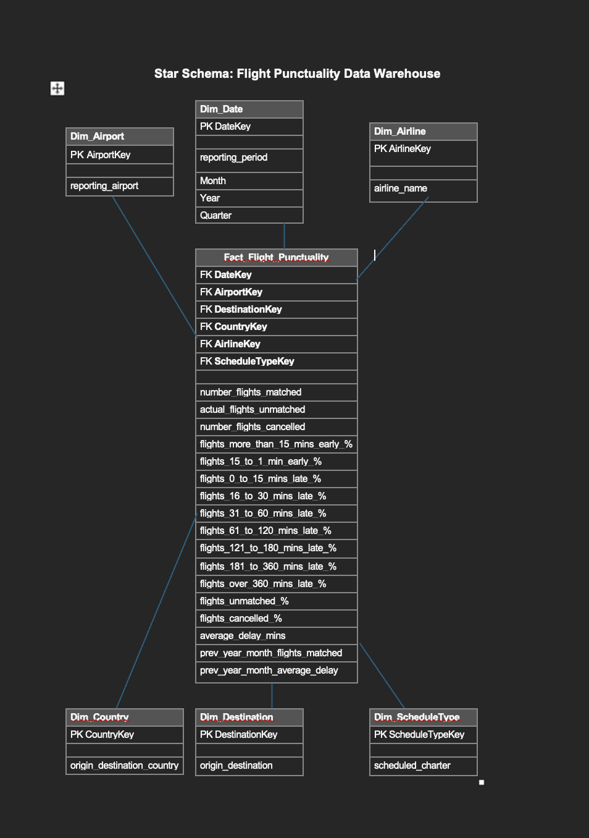

Fact Table Explained

Fact_Flight_Punctuality
Column Name | Description
DateKey | Links to date dimension
AirportKey | Links to airport
AirlineKey | Links to airline
ScheduleTypeKey | Scheduled or Charter
number_flights_matched | Total matched flights
number_flights_cancelled | Cancelled flights
average_delay_mins | Average delay
Justification:
The fact table stores quantitative flight performance measures such as delays, cancellations, and matched flights. This allows aggregation and analysis across multiple dimensions such as time, airline, and airport.

Dimension Tables Explained
Dim_Date
Column | Description
reporting_period | Original time field
Month | Derived month
Year | Derived year
Quarter | Derived quarter
Justification:
The date dimension was created from the reporting_period field. Additional attributes such as month, year and quarter were derived to support time-based analysis and trend reporting.

Dim_Airport
Column | Description
reporting_airport | Airport name
Justification:
Airports were separated into a dimension to reduce redundancy and support filtering and grouping in reports.

Dim_Airline
Column | Description
airline_name | Airline name
Justification:
Airline names were standardised during cleaning and placed in a dimension table to ensure consistency and improve reporting accuracy.

Dim_ScheduleType
Column | Description
scheduled_charter | Scheduled / Charter
Justification:
This dimension stores standardised flight types, allowing users to compare Scheduled and Charter flights effectively.

Dim_Destination & Dim_Country
Justification:
These dimensions support geographical analysis by allowing users to analyse routes at both destination and country level.

Overall:A star schema was selected because it simplifies the data model and improves query performance for analytical workloads. Separating fact and dimension tables reduces data redundancy and ensures consistency across the dataset. This design aligns with business intelligence best practices and supports efficient reporting in Tableau.

Question 3
The process of creating and populating the database began with preparing the source data in Tableau Prep. Multiple CSV files from different years were combined using a union operation to form a single dataset. Several data cleaning and transformation tasks were performed, including removing duplicate rows, trimming leading and trailing spaces, standardising airline names, replacing airport codes with full names, and ensuring consistent values in the scheduled_charter field.
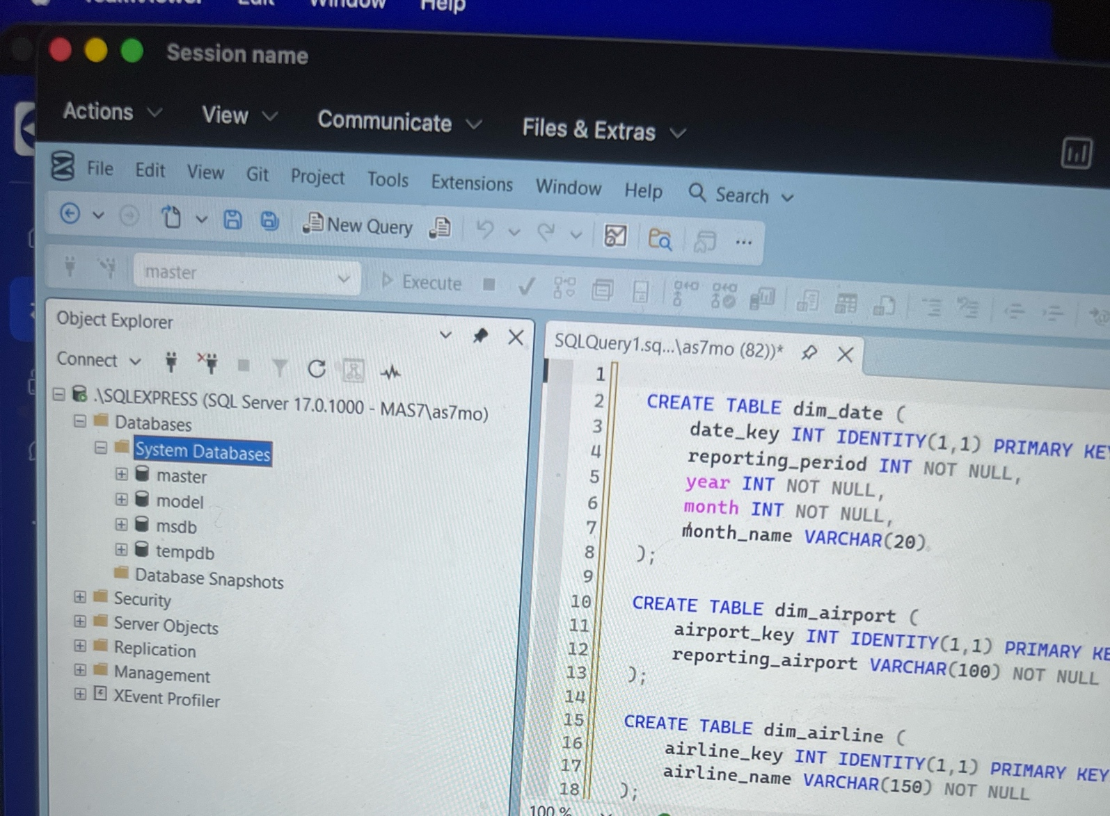
Once the data was cleaned, a data warehouse was designed using a star schema. This included a central fact table to store flight performance metrics and several dimension tables to store descriptive attributes such as airport, airline, destination, country, date, and schedule type.
SQL CREATE TABLE statements were then written to define the structure of the database, including primary keys for each dimension table and foreign keys in the fact table to establish relationships.
The cleaned dataset was then used to populate the database. Unique values were inserted into the dimension tables, while the numerical performance data was inserted into the fact table. This resulted in a fully populated data warehouse ready for analysis.
Screenshots of the populated tables have been included to demonstrate that the data was successfully loaded into the database.

Creating and Populating the Database
The database was created using a star schema design to support flight performance analysis. The original dataset was first reviewed to identify the key entities, measures and attributes. The main measurable values, such as number of matched flights, cancelled flights, delay percentages and average delay minutes, were placed into the fact table. Descriptive fields such as airline, airport, destination, flight type and reporting period were separated into dimension tables.
Before creating the database, the data was cleaned and prepared. Column names were standardised, missing values were checked, and fields were reviewed to ensure they used suitable data types. The reporting_period field was treated as a time attribute and broken down into year and month values for the date dimension. Text-based fields such as airline_name, reporting_airport and origin_destination were placed into separate dimension tables to reduce duplication.
The database tables were then created using SQL CREATE TABLE statements. Each dimension table was assigned a surrogate primary key using an integer key. The fact table included these surrogate keys as foreign keys, allowing it to link to the relevant dimensions. This structure improved data consistency and followed star schema principles.
After the tables were created, the dimension tables were populated first. Distinct values were inserted into each dimension table, such as unique airlines, airports, destinations and flight types. The fact table was then populated by matching the original dataset to the correct surrogate keys from each dimension table. The numeric performance measures were inserted into the fact table alongside the foreign keys.
The main transformation tasks performed included:
removing duplicate dimension values
converting the reporting period into year and month fields
separating descriptive attributes from measurable facts
assigning surrogate keys to dimension records
linking the fact table to dimension tables using foreign keys
ensuring percentage and delay fields used appropriate numeric data types
Screenshots of the populated tables should be included below.

Database Creation and Population
The process of creating and populating the database followed a structured ETL (Extract, Transform, Load) approach to ensure data consistency, integrity and suitability for analytical querying.

1. Data Preparation
The dataset was originally provided as a CSV file (output.csv). Prior to importing, the data was reviewed to ensure quality and consistency. This included:
Removing any duplicate records where necessary
Ensuring consistent column naming conventions
Verifying data types (e.g. numeric fields for delays, percentages, and flight counts)
Checking for missing or null values that could impact analysis
This step ensured the dataset was clean and ready for integration into a relational schema.

2. Database Design (Schema Creation)
A star schema was implemented to support analytical queries. This consisted of:
Dimension tables: dim_date, dim_airport, dim_airline, dim_destination, dim_flight_type
Fact table: fact_flight_performance
Each dimension table stores descriptive attributes, while the fact table stores measurable metrics such as:
Number of flights matched
Number of cancellations
Delay percentages
Average delay minutes
Primary keys were created for each dimension table, and foreign key relationships were established in the fact table to maintain referential integrity.

3. Data Loading (Staging Layer)
The CSV file was imported into SQL Server using the Import Flat File Wizard in SSMS.
The data was first loaded into a staging table:
stg_flight_data
This staging layer acted as an intermediate step, allowing transformation and validation before populating the final schema.

4. Data Transformation
Several transformation tasks were performed to align the raw data with the star schema:
De-duplication using SELECT DISTINCT to populate dimension tables
Extraction of date attributes:
Year and month were derived from the reporting_period field
Month names were generated using SQL date functions
Standardisation of categorical data such as airport names, airline names, and flight types
Ensuring all foreign key relationships could be correctly mapped
These transformations ensured that the data was normalised and optimised for analytical queries.

5. Populating Dimension Tables
Each dimension table was populated using distinct values from the staging table.
For example:
Airports were inserted into dim_airport
Airlines into dim_airline
Destinations into dim_destination
This reduced redundancy and ensured consistency across the database.

6. Populating the Fact Table
The fact table was populated by joining the staging table with all dimension tables to retrieve the corresponding keys.
This step ensured that:
- Each record in the fact table references valid dimension records
- The data model supports efficient querying and aggregation

7. Data Validation
After loading, validation checks were performed to confirm successful population:
Row counts were verified between staging and fact tables
Sample queries were executed to ensure data accuracy
Tables were inspected in SSMS to confirm correct structure and relationships

Overall, the process ensured that raw CSV data was transformed into a structured, relational format suitable for multi-dimensional analysis, supporting efficient querying and insight generation.

This screenshot shows the added database:
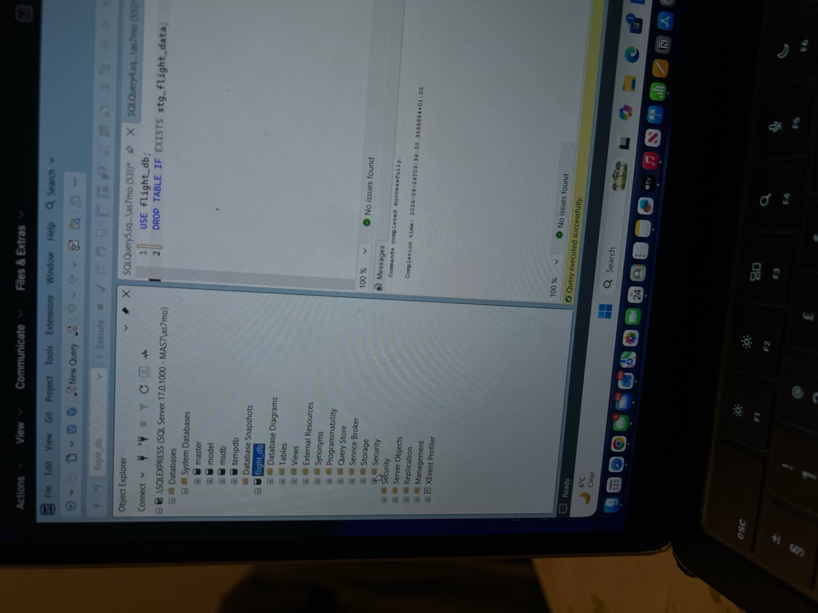
Question 5
The OLAP cube makes it easier to analyse flight punctuality by allowing data to be explored through multiple dimensions such as the destination, time, airport and airline. This helps to identify patterns, for example airports that consistently have high flight delays or specific periods when cancellations increase. By looking at the cancellations and delay rates together, it becomes possible to look into relationships between them.For instance, frequent delays at a particular airport could lead to an increased chance of cancellations which emphasises operational inefficiencies.

Including a time-based travel analysis means that you can now identify seasonal trends. There may be times of the year where there are increased delays and cancellations due to factors such as poor weather conditions or increased travel demand. In addition, using geographical analysis can highlight regions that experience more disruptions than others.

From a decision-making perspective, airlines and airports can use this information to manage their resources more effectively and improve flight scheduling. This would help to reduce the number of cancellations and number of delays. An example of this is, identifying peak delay periods can help allow for better staff planning and recognising routes and airports that are underperforming can support targeted improvements.

Overall, the OLAP cube turns raw data into more useful and actionable insights which in retum helps the industry make informed, data driven decisions.

The Three OLAP Operations is as follows:
The OLAP cube supports multiple analytical operations that allow users to explore the data effectively.
1. Drill-Down
- Drill-down allows users to move from a higher level of aggregation to a more detailed level.
Example:
A user can analyse average delay at a yearly level and then drill down into monthly data to identify specific periods where delays were significantly higher.

2. Roll-Up
- Roll-up aggregates data to a higher level within a hierarchy.
Example:
Monthly flight delay data can be rolled up to yearly averages to identify overall trends in airline punctuality over time.

3. Slice
- Slice filters the cube based on a single dimension value.
Example:
A user can analyse only one airport (for example Heathrow) to evaluate its delay and cancellation performance independently from other airports.

The OLAP cube enables efficient analysis of flight punctuality by allowing data to be explored across multiple dimensions such as time, airline, airport and destination. This supports research by identifying patterns, such as airports with consistently high delays or periods where cancellations increase.
By analysing both delays and cancellation rates, the cube allows stakeholders to investigate potential relationships between these variables. For example, frequent delays at a specific airport may contribute to a higher likelihood of cancellations, highlighting operational inefficiencies.

The inclusion of time-based analysis enables identification of seasonal trends, where increased delays and cancellations may occur due to factors such as adverse weather conditions or peak travel demand. Additionally, geographical analysis can highlight regions with higher disruption levels.

For decision-making, airlines and airports can use these insights to improve scheduling, allocate resources more effectively and reduce operational disruptions. For example, identifying peak delay periods allows for better staff planning, while recognising underperforming routes or airports supports targeted improvements.Overall, the cube transforms raw data into actionable insights, enabling more informed and data-driven decisions within the airline industry.

Question 6
Map Visual: A map visual was used to show which country had the most matched flights, the darker the country, the higher the number of matched flights. This field was chosen over unmatched flights as the dataset was more reliable. A calculated field was created (called “Cancellation Rate”) to measure the cancellation figure across different destinations. The formula divides the total number of cancelled flights by the total number of matched flights, ensuring an aggregated and accurate representation of cancellation rates at country level. This metric was then visualised on a filled map, as a tooltip just like the total number of flights cancelled with the information of the name of the country. This gives the person victualing the data more clarity and make informed decision.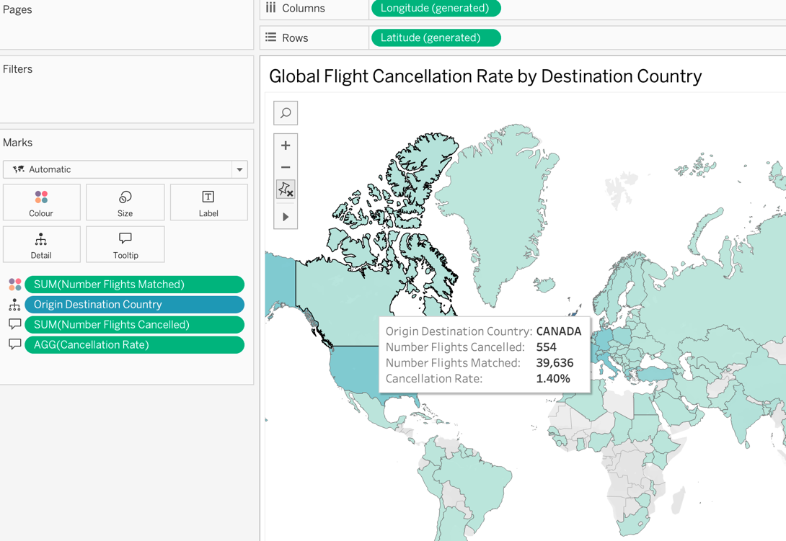
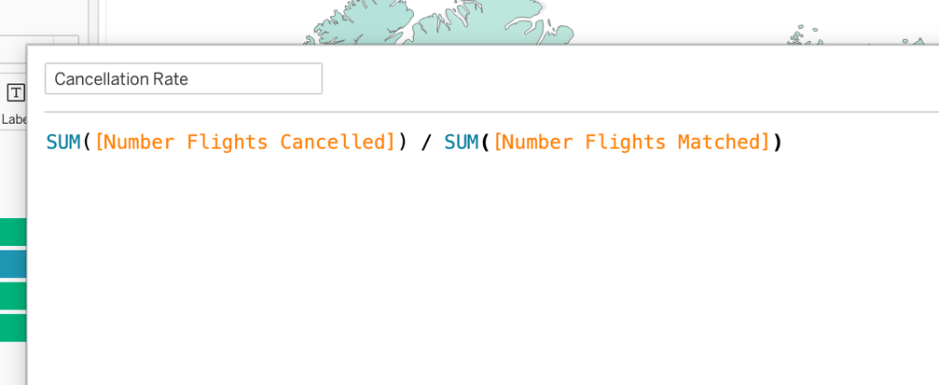

Stacked Bar chart: This visual presents the average delay (in minutes) by airline. The stacked bar chat was used to make it easier for stateholders to visually see which airline has the most delayed flights to then find solutions on how to reduce it.A year filter has been applied using the reporting period, allowing the analysis to focus on a specific time frame. This ensures that comparisons are meaningful and not distorted by aggregating data across multiple years.
From the visual, it is clear that there is significant variation in delay performance between airlines. Some airlines exhibit relatively low average delays, indicating efficient operations and effective scheduling. In contrast, others show substantially higher delay values, suggesting potential operational challenges or inefficiencies. In the screenshot below, Rwandair Express has the highest average delay.
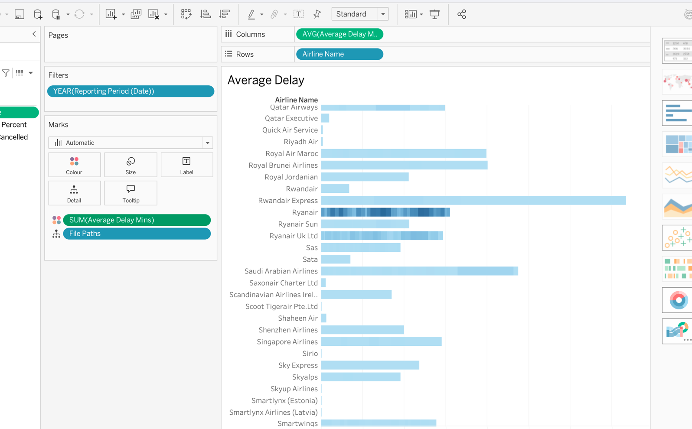

Line Graph: This line chart shows how average flight delays changed across each month. The delay level increased from January to February, dropped around April to June, then rose sharply from August onwards. The highest average delay appears around September, before gradually decreasing towards December.This visual was created by placing Run Date on columns and the calculated field Average Delay Minutes on rows. A line chart was used because it clearly shows changes and trends over time.
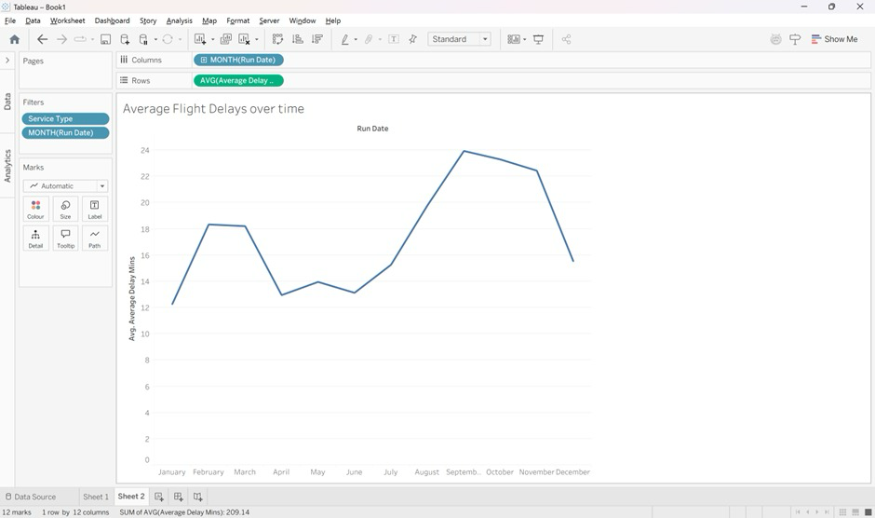

Stacked Bar chart: This bar chart compares the number of matched flights across UK reporting airports, split by service type: scheduled and charter flights. The visual shows that Heathrow has the highest number of matched flights, followed by Gatwick and Manchester. Most flights are scheduled, while charter flights make up a much smaller proportion. This visual was created by placing Reporting Airport on rows and Number Flights Matched on columns. Service Type was added to colour so that scheduled and charter flights could be compared within each airport. An airline filter was also added to allow the data to be narrowed down by airline.

